**3.** **Planning & Task Clarification**

(Planning, identifying users, collecting need statements, and generating initial problem statement)

This phase of product development is crucial as all the planning, identification of users, understanding the need of the users, and generating an initial problem statement that helps in directing the design toward one that solves the problem of the users, is understood and documented.

There are multiple steps that are followed to get the required data that will allow the development of the solution to start.

**3.1** Planning & Scheduling:

In this step, all the tasks that need to be done are listed and a timeline is put down so that the Agile methodology can be used in conjunction with design thinking and engineering design to create independent tasks that can be accomplished in sprints.

The following steps are followed in design thinking:

1. **Identification of users and creating user stories:**

In this step, the team members approach people that could help them better understand the problem that the team has decided to solve.

After interacting with many people, users are identified. There are people that are really in need of a solution to the problem and are willing to help the team by giving a description of the problem and how it is affecting their quality of life.

Following are the user stories that were generated after identifying users:

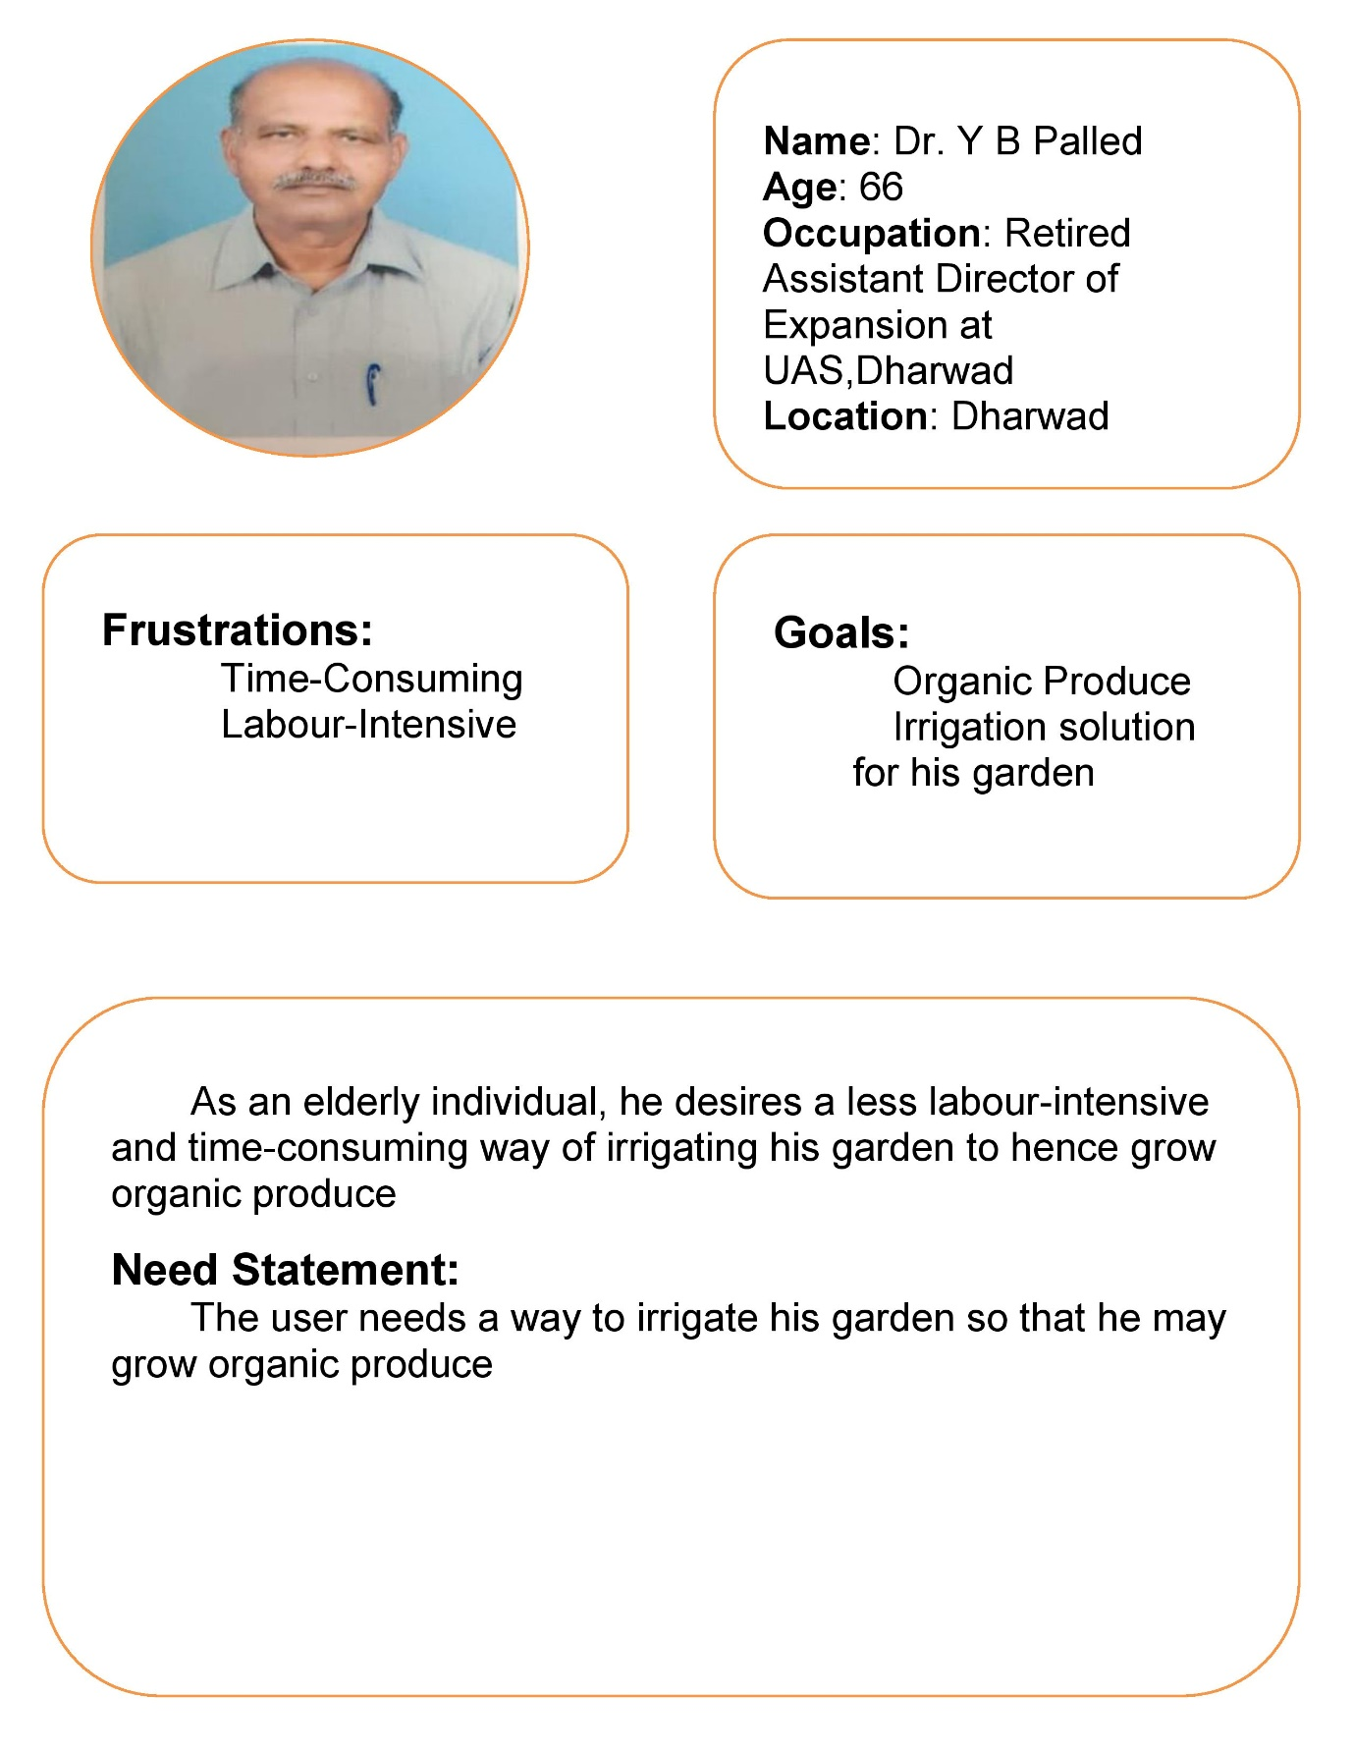

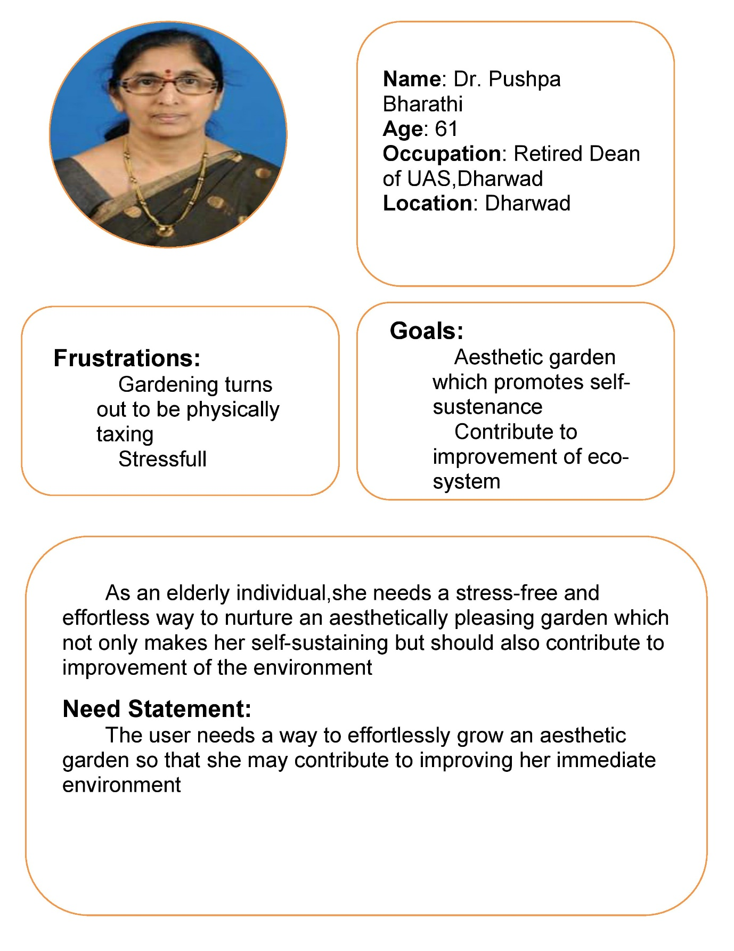

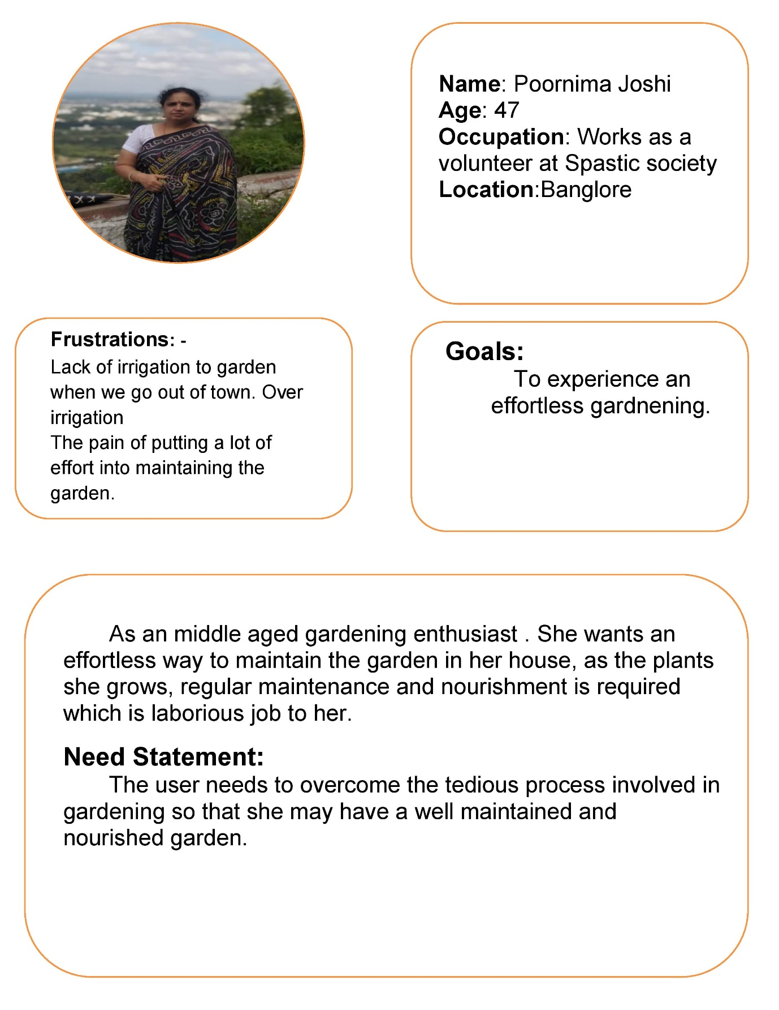

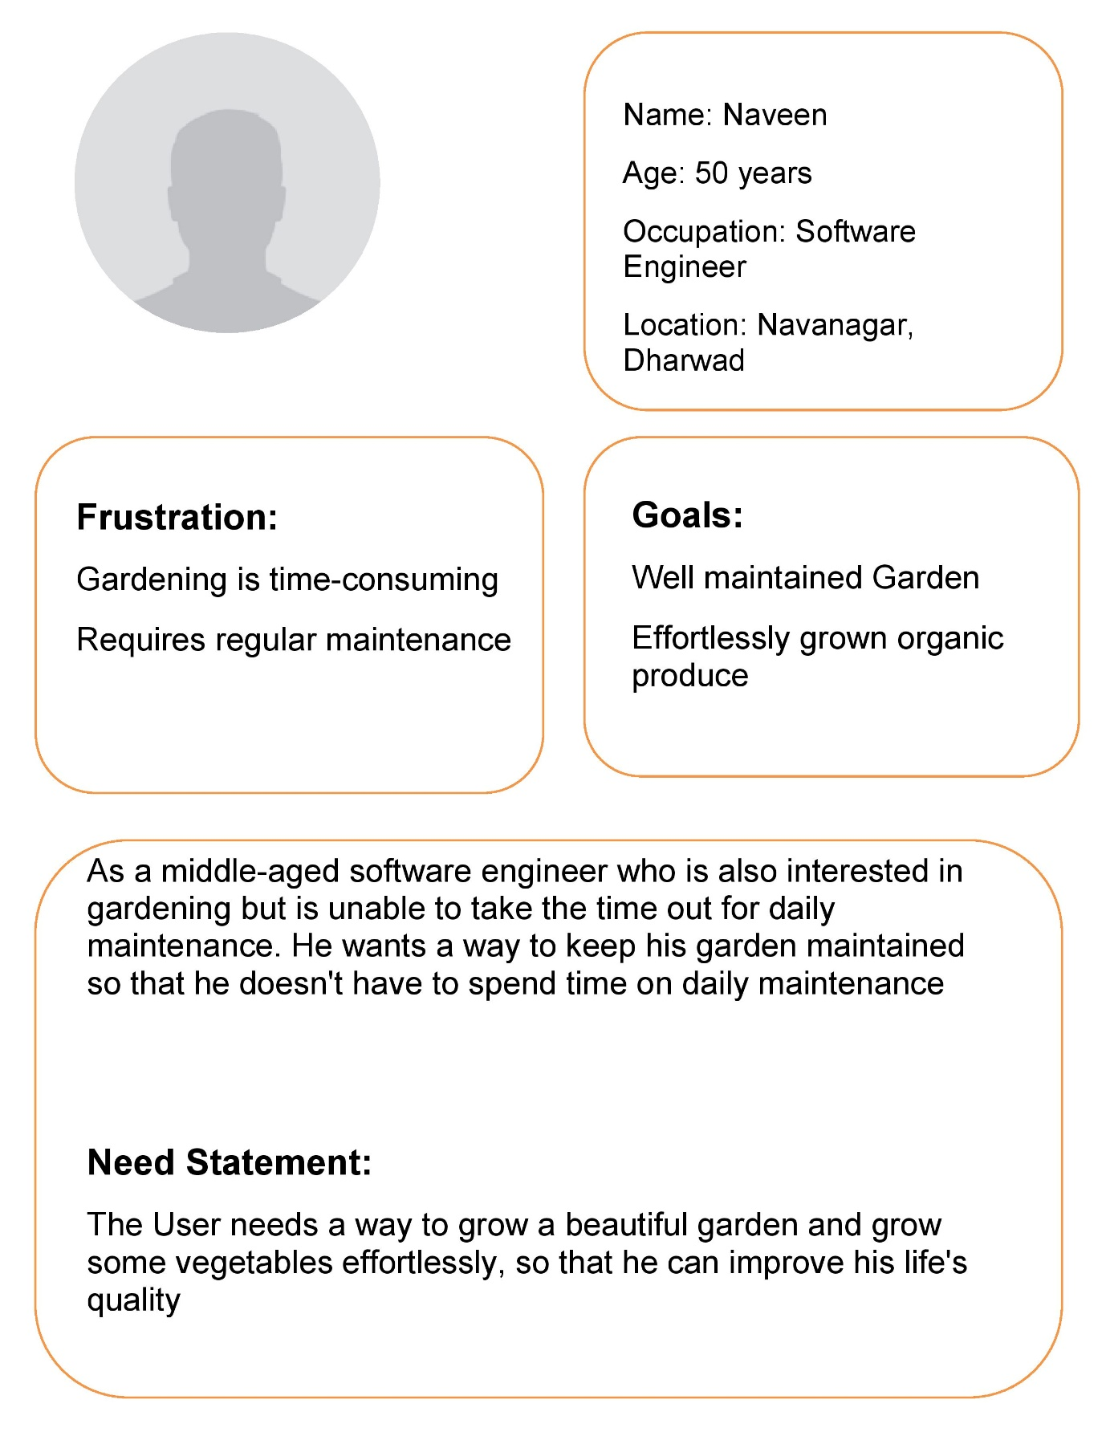

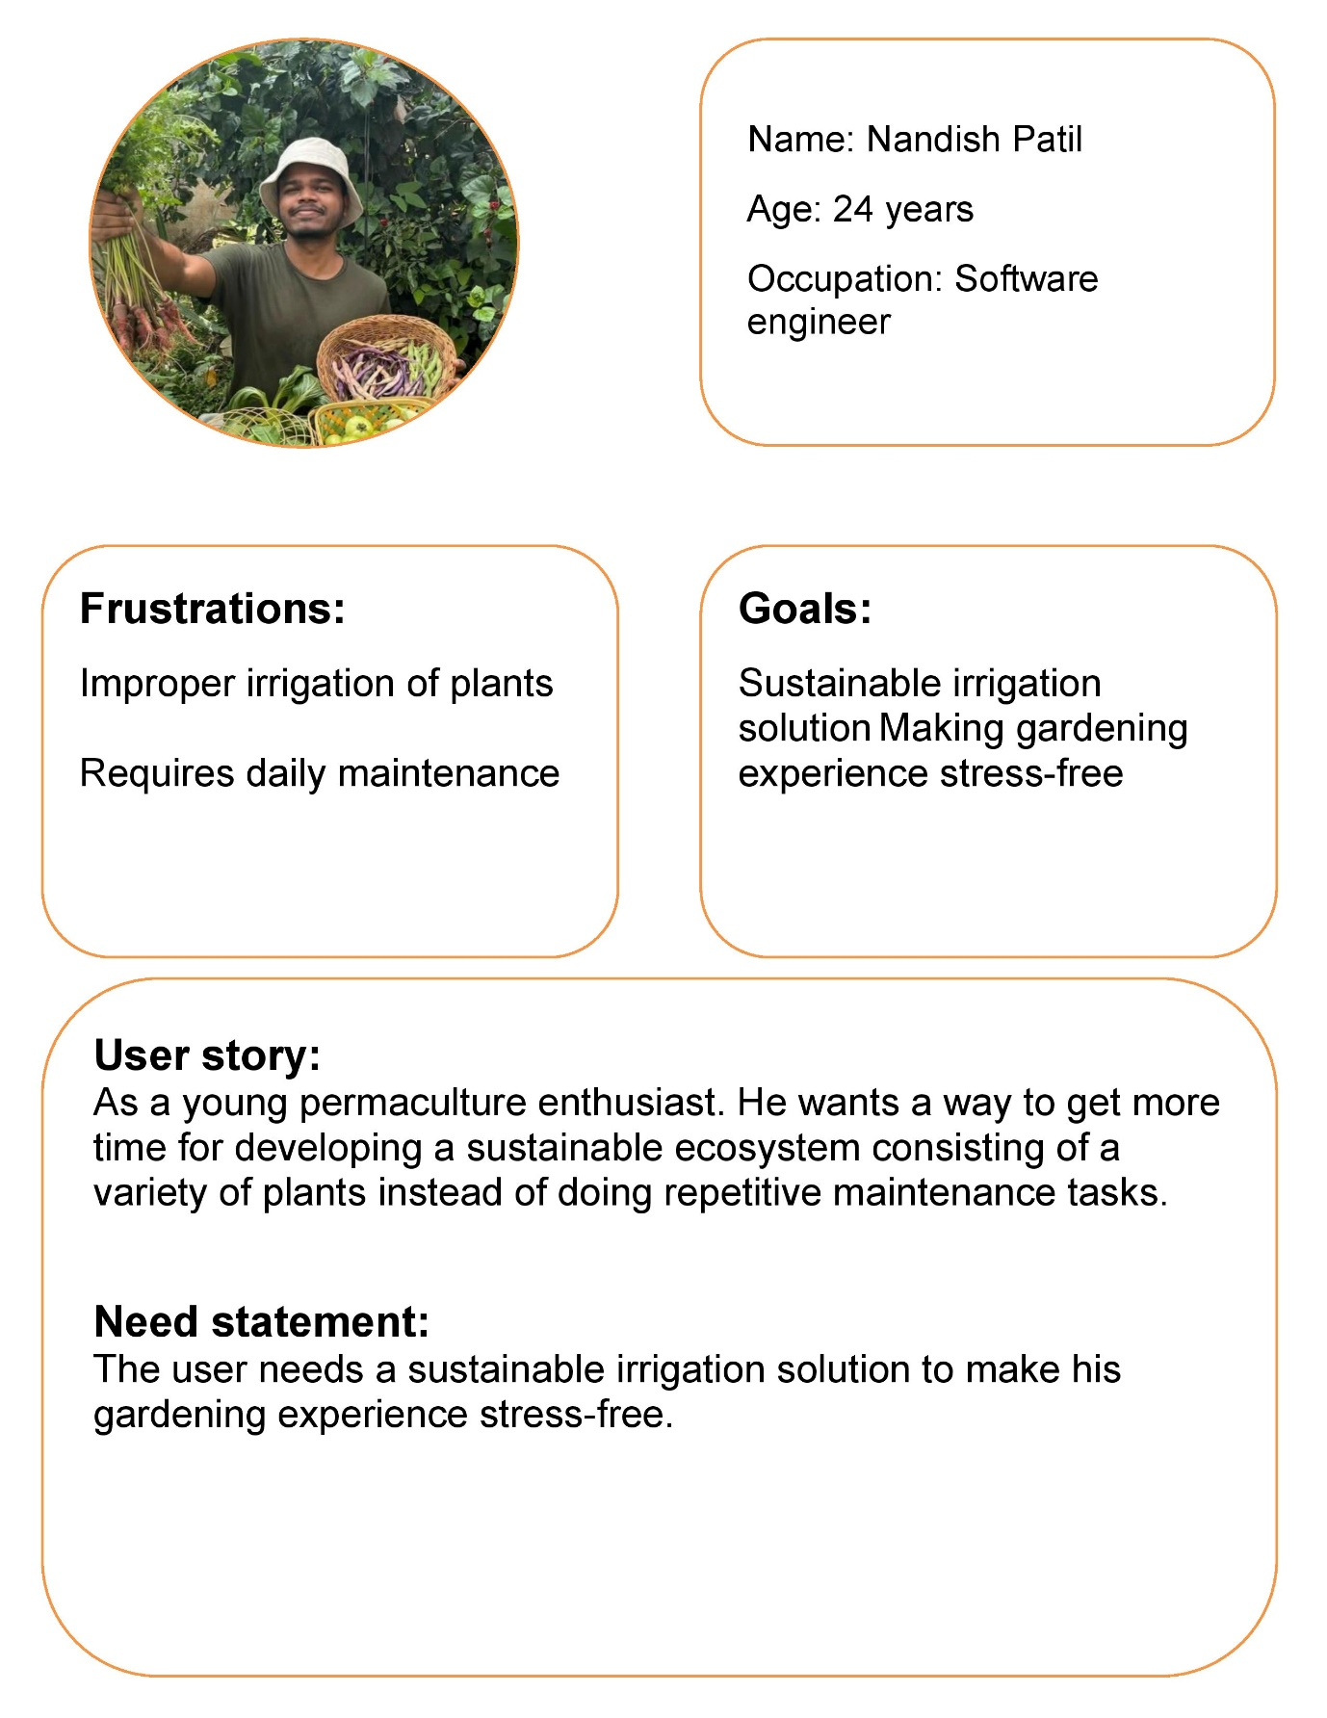

1. **Empathy map:**

By looking at these user stories an empathy map is created which helps the team empathize with the user’s situation

The empathy map consists of these sections’ pains, gains, thinks & feels, sees, and hears all these sections together give us an understanding of the user’s situation. It is essential to understand the user’s situation or the environment they live in so that the product or solution that is being designed can best fit their needs.

Below is the picture of the empathy map that was created after going through the user stories:

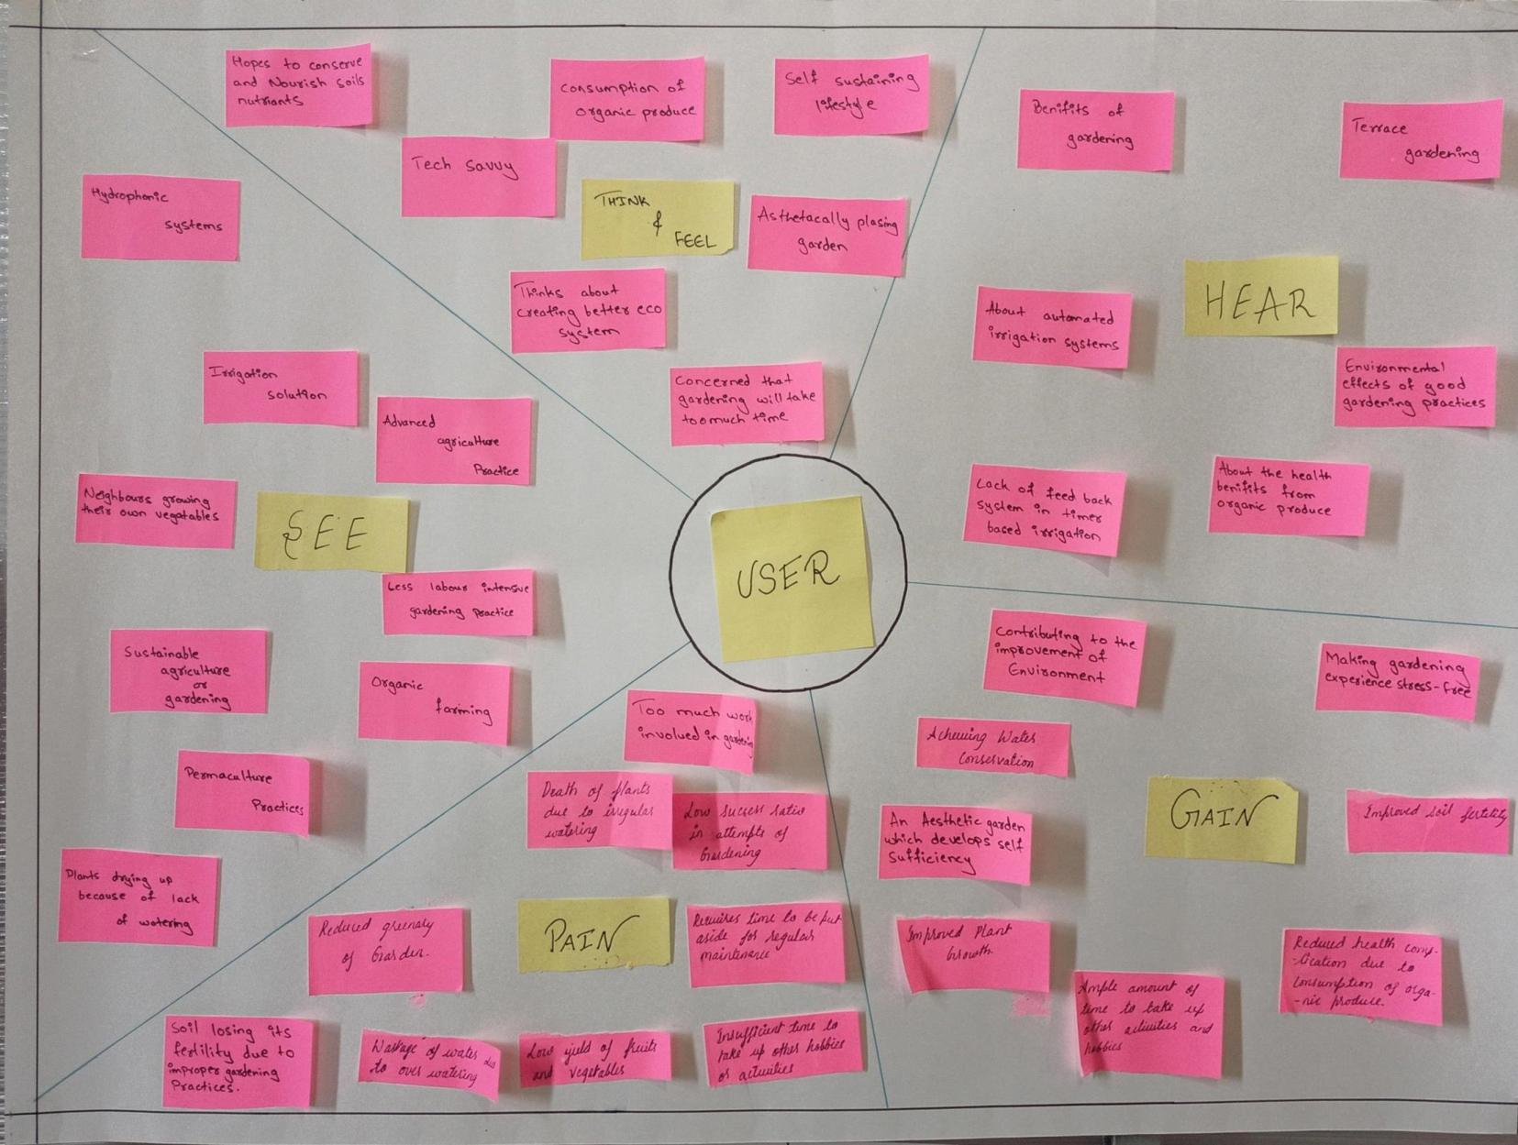

1. **User stories:**

The next step in design thinking is to create user stories that only address one point so that they can be prioritized and worked on. These user stories address all the entities that are going to be interacting with the solution or product that includes the end users as well as entities that are involved in the transportation, repair, installation, sales, and customer care.

Multiple aspects of the product need to be addressed so that the customers find value in the product or solution. In order to address all the aspects of the product or solution the user stories with their acceptance criteria are split up into reach, acquisition, activation, retention, and loyalty.

Below are the user stories:

Reach: -

US-01: Cost: -

   While searching for a solution the users need a cost-effective

solution that is financially viable for them.

Acceptance criteria:

When the user goes to buy the product Then they must find the

product to be cost-effective.

US-02: Aesthetic features: -

   While looking for a solution the user needs the solution to be

aesthetically pleasing so that it improves the overall aesthetic of

the garden.

Acceptance criteria:

When the user looks at the product Then they must find the

product aesthetically pleasing.

US-03: Product packaging: -

   While looking for a solution the user needs it to be packaged well

so that the product is delivered undamaged.

Acceptance criteria:

When the user observes the packaging of the product Then they

must find the packaging sturdy and the product undamaged.

US-04. More features compared to other competitors: -

While looking for a solution, the user needs the product to have

more features compared to its competitors so choosing the product

turns out to be beneficial for them

Acceptance criteria:

When the user compares the product to other solutions then the

user must find the product to be more endowed with features.

US-05. Satisfy the user’s basic needs: -

While looking for a solution, the user needs the product to satisfy

their basic requirements so that their needs are fulfilled.

Acceptance criteria:

When the user utilizes the product then their basic need should be

fulfilled

Acquisition: -

US-06: Build quality: -

   The user while acquiring the product needs it to have a sturdy

build quality so that it can withstand heavy /rough usage.

Acceptance criteria:

When the user goes to buy the product, then it must have good

build quality.

US-07: Handy to use/Ergonomic: -

   The user needs it to be ergonomic so that it is handy to use.

Acceptance criteria:

When the user goes to buy the product Then the product must have

good ergonomics.

US-08: Can be used in various situations: -

  The user needs a versatile solution so that it can be used in various

applications

Acceptance criteria:

When the user goes to buy the product Then the product must be

versatile in nature.

US-09: Compact:

The user needs a compact solution so that it does not take up too

much space in their gardens.

Acceptance criteria:

  When the user installs the product in their garden then it must take

up less space.

 US - 10: Capability: -

The User needs the product to have the capability to perform its

intended functionality so that the user’s initial requirement is

fulfilled.

Acceptance criteria:

When the product begins operation then it must be able to

perform its expected functionality.

US - 11: Modularity: -

The user needs the product to be modular so that the parts can be

easily replaced, should something go wrong.

Acceptance criteria:

  When a component in the product is faulty then it needs to be easy

to replace.

Activation: -

US -12: Easy installation

After Acquiring the product, the user needs the product to be easy

to install so that it is easy to accommodate in their existing garden.

Acceptance criteria:

When the user buys the product Then the product must be easy to

install.

US - 13: Easy to use

After Acquiring the product, the user needs the product to be easy

to use so that it can be used effortlessly.

Acceptance criteria:

When the user buys the product Then the product must be easy to

use/operate.

US - 14: Easy to understand the user manual: -

After Acquiring the product, the user needs the user manual to be

easily understood so that they can use the product properly.

Acceptance criteria:

When the user buys the product Then the user manual must be

easy to understand.

Retention: -

US - 15: Reliable operation

While using the product, the users need the product to be reliable

so that it does not intervene with their daily routines.

Acceptance criteria:

When the user uses the product Then the product should not

disturb their daily routines.

US - 16: Less human interaction/Automatic: -

While using the product, the user needs the product to require

minimal interaction so that they can focus on other activities.

Acceptance criteria:

When the user uses the product Then the product must require

minimal human interaction.

US - 17: Conservation of resources: -

While using the product, the user needs the product to work

effectively so that it conserves their overall resources.

Acceptance criteria:

When the user uses the product Then the product must utilize

minimal resources (Time, Water, & Money).

US - 18: Less maintenance: -

While using the product, the user needs the product to require less

maintenance so that they don't have to regularly put in service

requests.

Acceptance criteria:

When the user uses the product Then the product must require

minimal maintenance.

Loyalty: -

US - 19: Good customer service: -

After having used the product for a prolonged time, the user needs

the product to have good customer service so that they receive

regular assistance on queries related to their product.

Acceptance criteria:

When the user has a query regarding the product Then the

necessary customer service must be provided.

US - 20: regular maintenance: -

After having used the product for a prolonged time, the user needs

the product to undergo regular maintenance so that it functions

ideally throughout its operating lifespan.

Acceptance criteria:

When the product is being utilized by the user Then the product

must be regularly maintained so as to avoid faults in the product.

US - 21: Regular upgrades to the product: -

After having used the product for a prolonged time, the user needs

the product to have regular upgrades so that it stays up-to-date so

as meet the users’ needs.

Acceptance criteria:

When the product is being used by the user Then the product must

receive regular upgrades so as to meet the users’ requirements

effectively.

1. **Categorisations into demands and desires**

The user stories are sorted into two categories demands and desires. The demands are usually the basic needs of the users, and the product or solution must satisfy them. Desires are usually luxuries that make interacting with the product or solution a pleasant experience.

Below is the list of demands and desires:

|  |  |
| --- | --- |
| Demand | Desire |
| US - 01 | US - 02 |
| US - 03 | US - 04 |
| US - 05 | US - 07 |
| US - 06 | US - 08 |
| US - 09 | US - 13 |
| US - 10 | US - 16 |
| US - 11 | US - 21 |
| US - 12 |  |
| US - 14 |  |
| US - 15 |  |
| US - 17 |  |
| US - 18 |  |
| US - 19 |  |
| US - 20 |  |

1. **Requirement generation:**

In this phase the user stories are converted into requirements this is done by evaluating the acceptance criteria in each of the user stories. In addition to user stories, acceptance criteria can also be used as a tool to generate requirements for a system. Acceptance criteria are specific, measurable, and testable conditions that a system must meet in order to be considered "done" or ready for acceptance. These criteria are typically derived from the user stories and provide a clear and objective way to determine whether the system meets the requirements of the end user.

To generate requirements from user stories using acceptance criteria, the first step is to identify the specific goals or actions that the user wants to achieve, as described in the user stories. Once these goals or actions have been identified, the next step is to define acceptance criteria that describe the conditions that must be met in order for the system to be considered ready for acceptance. For example, if the user story is "As a customer, I want to be able to purchase products online so that I can shop from the convenience of my own home," the acceptance criteria might include:

The system must have a secure payment system.

The system must have a catalogue of available products.

The system must have the ability to track and fulfill orders.

The system must be easy to use and navigate.

These acceptance criteria can then be used as the basis for generating the specific requirements that are needed to support the goals and actions described in the user stories. In addition to providing a clear and objective way to determine whether the system is ready for acceptance, the use of acceptance criteria can also help to ensure that the system being developed meets the needs of the end user and supports the desired functionality.

|  |  |  |
| --- | --- | --- |
| R.No | Source | Requirement |
| 1 | Survey | The price should be less than 10000 Rs |
| 2 | Team | Should be priced at less than 15% of competitors |
| 3 | Client | No Compromises must be made in the build quality due to low pricing |
| 4 | Client | Smooth surface finish |
| 5 | Client | Glossy appearance |
| 6 | Client | The product should have Unique colors |
| 7 | Team | The product must consist of a unique Geometry |
| 8 | Survey | Packaging should withstand any situations |
| 9 | Team | Packaging should handle at least 4ft. fall without causing any damage to the product |
| 10 | Team | Easy to hold and move by a single person |
| 11 | Survey | Packaging should be light in weight & cost-effective |
| 12 | Team | Should be easy to Carry/Handle |
| 13 | Team | Should have no sharp edges and should be child-friendly |
| 14 | Survey | Should not cost more than 10000 Rs |
| 15 | Team | Should cost 10% less than its competitors |
| 16 | Team | Should conserve at least 15% fewer resources compared to competitors |
| 17 | Client | Safe to use |
| 18 | Client | Should Work in required Conditions |
| 19 | Team | The product should withstand heavy/rough usage |
| 20 | Team | The product should be made up of good-quality materials |
| 21 | Team | The product should at least handle a 3 ft fall without any substantial damage |
| 22 | Survey | Should be easy to hold |
| 23 | Survey | Should have minimal sharp edges |
| 24 | Team | Should be installable in any garden |
| 25 | Survey | Suitable for smaller gardens |
| 26 | Survey | Size should be less than 2 cubic feet |
| 27 | Team | Maintains Moisture level of soil |
| 28 | Client | Aids in the growth of plants |
| 29 | Client | Consumes fewer resources |
| 30 | Team | Replacement parts should be readily available |

1. Requirements are classified based on metrics, these metrics can be used to measure the success of the project, and to determine if the requirements have been adequately met. Additionally, metrics can be used to prioritize requirements, with higher-importance requirements having more stringent metrics, and lower-importance requirements having less stringent metrics.

The below table is created which categorizes the requirements:

|  |  |  |  |  |
| --- | --- | --- | --- | --- |
|  | Requirement | Importance | D/W | Category |
|  | The price should be less than 10000 Rs | 4 | Demand | Cost |
|  | Should be priced at less than 15% of competitors | 4 | Demand | Cost |
|  | No Compromises must be made in the build quality due to low pricing | 7 | Demand | Quality Control |
|  | Smooth surface finish | 5 | Wish | Material |
|  | Glossy appearance | 5 | Wish | Material |
|  | The product should have stand-out colours | 5 | Wish | Material |
|  | The product must consist of a unique geometry | 5 | Wish | Geometry |
|  | Packaging should withstand any situations | 5 | Demand | Transport |
|  | Packaging should handle at least 4ft. fall without causing any damage to the product | 5 | Demand | Transport |
|  | Easy to hold and moved along by a single person | 5 | Demand | Transport |
|  | Packaging should be light in weight & cost-effective | 5 | Demand | Transport |
|  | Should be easy to Carry/Handle | 6 | Wish | Ergonomic |
|  | Should have no sharp edges and should be child-friendly | 10 | Wish | Safety |
|  | Should not cost more than 10000 Rs | 4 | Wish | Cost |
|  | Should cost 10% less than its competitors | 4 | Wish | Cost |
|  | Should conserve at least 15% less overall resources compared to competitors | 7 | Wish | Energy |
|  | Safe to use | 10 | Demand | Safety |
|  | Should Work in required Conditions | 7 | Demand | Operation |
|  | The product should withstand heavy/rough usage | 6 | Demand | Ergonomic |
|  | The product should be made up of good-quality materials | 5 | Demand | Materials |
|  | The product should at least handle a 3 ft fall without any substantial damage | 7 | Demand | Quality Control |
|  | Should be easy to hold | 6 | Wish | Ergonomic |
|  | Should have minimal sharp edges | 6 | Wish | Ergonomic |
|  | Should be installable in any garden | 6 | Wish | Ergonomic |
|  | Suitable for smaller gardens | 7 | Demand | Operation |
|  | Size should be less than 2 cubic feet | 5 | Demand | Geometry |
|  | Maintains Moisture level of soil | 7 | Demand | Operation |
|  | Aids in the growth of plants | 7 | Demand | Operation |
|  | Consumes fewer resources | 7 | Demand | Energy |
|  | Parts should be readily available | 5 | Demand | Maintenance |
|  | Parts should be easily detached | 5 | Demand | Assembly |
|  | Parts should be reasonably priced | 4 | Demand | Cost |
|  | Should have standard attachment brackets | 5 | Demand | Geometry |
|  | Should use fewer fasteners | 6 | Demand | Assembly |
|  | A technician with a medium level of expertise should be able to install it | 5 | Demand | Assembly |
|  | Installation should not take more than 2 hrs | 6 | Demand | Assembly |
|  | Should be installable by general tools | 6 | Demand | Assembly |
|  | No requirement of any platform base for installation | 6 | Demand | Assembly |
|  | Should require less than 5 user inputs to operate | 7 | Wish | Operation |
|  | The user interface should not be complicated so that it can be used by a variety of age groups | 7 | Wish | Operation |
|  | There should be a set of simple instructions for maintenance | 5 | Wish | Maintenance |
|  | The user’s manual should not be more than 10 pages | 5 | Wish | Maintenance |
|  | The manual should contain mostly pictorial representations of the instructions | 5 | Wish | Maintenance |
|  | The manual should be available in the form of paperback as well as online | 7 | Wish | Ease of use |
|  | Textual content should be in English as well as in the regional language | 7 | Wish | Ease of use |
|  | The user should have less than two or three interactions per day | 7 | Demand | Operation |
|  | The interactions should not take more than 10 min of the user’s time | 7 | Demand | Operation |
|  | The product should require minimal interaction | 7 | Wish | Operation |
|  | The product should not interfere with their schedule | 7 | Wish | Operation |
|  | At least 10% of water must be saved | 7 | Demand | Energy |
|  | Must consume less than 5kWatt/hr per month | 7 | Demand | Energy |
|  | Must require less than 2 hours to perform the operation | 9 | Demand | Time |
|  | Shouldn't breakdown often | 7 | Demand | Schedule |
|  | Facilitate simple maintenance | 5 | Demand | Maintenance |
|  | Provide long intervals between alternate maintenance schedules | 7 | Demand | Schedule |
|  | The user manual must be efficient to help the customer perform self-maintenance | 5 | Demand | Maintenance |
|  | The customer query must be responded to within 24 hrs | 9 | Demand | Time |
|  | Customer service is to be provided in English and regional languages | 6 | Demand | Simple understanding |
|  | Maintenance services Should be provided by the company | 5 | Demand | Maintenance |
|  | Pocket-friendly maintenance | 4 | Demand | Cost |
|  | Receive regular updates | 7 | Wish | Schedule |
|  | New upgrades solving additional problems | 7 | Wish | Operation |
|  | The product should be remotely controllable | 7 | Wish | Ease of use |
|  | Should notify the user when various tasks are completed | 7 | Wish | Operation |
|  | Should provide statistical data to the user | 7 | Demand | Operation |
|  | There should be safety mechanisms in place so that the components don't get damaged | 10 | Demand | Safety |
|  | The product should be moderately water resistant. | 6 | Demand | Assembly |
|  | The product should display the status of an operation | 7 | Wish | Operation |

3.3 Final problem statement:

**Final Problem Statement:**

*Develop a fail-proof, power-efficient, and cost-effective solution to regulate the soil moisture level of the garden to maintain the health of plants which is easy to install and operate for a layman.*

3.4: Competitive benchmarking:

Competitive benchmarking is the process of comparing products, processes, or services to those of its competitors in order to identify areas for improvement. This can help develop more competitive products, processes, or services, and identify opportunities for innovation. To conduct competitive benchmarking, key competitors are identified and information is gathered about their offerings. This information is then used to compare the products, processes, or services being developed to those of its competitors, and to identify areas where it can improve. The results of the competitive benchmarking process can inform product development decisions and help a develop a competitive product.

These are the steps that are followed to do competitive benchmarking:

The affinity groups are identified:

|  |  |  |
| --- | --- | --- |
| R No. | Sub-Category 1 | Category |
| 1 | Maximum Retail Price | Cost |
| 2 | Competitive Pricing | Cost |
| 3 | Uncompromised Build | Quality Control |
| 4 | Texture | Material |
| 5 | Texture | Material |
| 6 | Colour | Material |
| 7 | Design | Geometry |
| 8 | Package | Transport |
| 9 | Ergonomics | Transport |
| 10 | Package | Transport |
| 11 | Package | Transport |
| 12 | Handling | Ergonomic |
| 13 | Design | Safety |
| 14 | MRP | Cost |
| 15 | Competitive Pricing | Cost |
| 16 | Resource management | Energy |
| 17 | Safe operation | Safety |
| 18 | Reliability | Operation |
| 19 | Build quality | Ergonomic |
| 20 | Material properties | Materials |
| 21 | Build quality | Quality Control |
| 22 | Handling | Ergonomic |
| 23 | Design | Ergonomic |
| 24 | Compatibility | Ergonomic |
| 25 | Compatibility | Operation |
| 26 | Design | Geometry |
| 27 | Regulation | Operation |
| 28 | Commensalism | Operation |
| 29 | Resource management | Energy |
| 30 | Availability | Maintenance |
| 31 | Modularity | Assembly |
| 32 | Pricing | Cost |
| 33 | Modularity | Geometry |
| 34 | Resource management | Assembly |
| 35 | Installation | Assembly |
| 36 | time management | Assembly |
| 37 | Installation | Assembly |
| 38 | Installation | Assembly |
| 39 | Inputs | Operation |
| 40 | Operability | Operation |
| 41 | Instructions | Maintenance |
| 42 | Resource management | Maintenance |
| 43 | Pictorial representation | Maintenance |
| 44 | Availability | Maintenance |
| 45 | Lucid | Ease of use |
| 46 | Interactions | Ease of use |
| 47 | time management | Operation |
| 48 | Interactions | Operation |
| 49 | Time management | Operation |
| 50 | Resource management | Energy |
| 51 | Resource management | Energy |
| 52 | Time management | Time |
| 53 | Reliability | Schedule |
| 54 | Lucid | Maintenance |
| 55 | Service internal | Schedule |
| 56 | User manual | Maintenance |
| 57 | Customer Service | Time |
| 58 | Customer Service | Simple understanding |
| 59 | Customer Service | Maintenance |
| 60 | maintenance cost | Cost |
| 61 | Updates | Schedule |
| 62 | Upgrades | Operation |
| 63 | Control | Ease of use |
| 64 | Notification | Operation |
| 65 | Data presentation | Operation |
| 66 | Component management | Safety |
| 67 | Water resistances | Assembly |
| 68 | Notification | Operation |

Then the user stories are categorized under the metrics:

|  |  |  |  |
| --- | --- | --- | --- |
| Metric Number | Requirement Number | Metric | Units |
| 1 | 1,2,14,15,32,60 | Cost | Indian Rupees |
| 2 | 3,21 | Quality |  |
| 3 | 4,5,6,20 | Material |  |
| 4 | 7,26,33 | Geometry | mm^3, mm |
| 5 | 8,9,10,11 | Transport |  |
| 6 | 12,22,24,23,19 | Ergonomics | mm |
| 7 | 13,17,66 | Safety | Safety factor |
| 8 | 16,29,50,51 | Energy | Voltage, Litres, kWh |
| 9 | 18,25,27,28,39,40,46,47,48,49,62,64,75,68 | Operation |  |
| 10 | 30,41,42,43,54,56,59 | Maintenance | Days and Instances |
| 11 | 31,34,35,36,37,38,67 | Assembly | Hours |
| 12 | 44,45,63 | Ease of use |  |
| 13 | 52,57 | Time | Hours |
| 14 | 53,55,61 | Schedule | Days/months |
| 15 | 58 | Simple understanding |  |

Then the competitive benchmarking table is created:

|  |  |  |  |  |  |  |  |
| --- | --- | --- | --- | --- | --- | --- | --- |
| D S No. | Requirement Number | Metric | Importance | Units | Marginal value | Ideal value | Validation/Test Method |
| 1 | 1,2,14,15,32,60 | Cost | 4 | Indian Rupees | 5,000 Rs | 10,000 Rs | Quotation |
| 2 | 3,21 | Quality | 7 |  |  |  | Quality control, Stress analysis, and drop testing |
| 3 | 4,5,6,20 | Material | 5 |  |  |  | Material testing |
| 4 | 7,26,33 | Geometry | 5 | mm^3, mm | 350 mm^3 | 200 mm^3 | Drafts |
| 5 | 8,9,10,11 | Transport | 5 |  |  |  | Transport quotation |
| 6 | 12,22,24,23,19 | Ergonomics | 6 | Mm, number of sharp edges | 2 sharp edges | 0 sharp edges | On hand comparison |
| 7 | 13,17,66 | Safety | 10 | Safety factor | More than 1.75 | More than 1.5 | Safety ratings |
| 8 | 16,29,50,51 | Energy | 7 | Voltage, liters, KWh | 220v, 2 kWh per month | 220 v, 1Kwh per month | Energy ratings |
| 9 | 18,25,27,28,39,40,46,47,48,49,62,64,65,68 | Operation | 7 |  |  |  | On-site performance review |
| 10 | 30,41,42,43,54,56,59 | Maintenance | 5 | Days and Instances | 1 month | 1 month | User review |
| 11 | 31,34,35,36,37,38,67 | Assembly | 6 | Hours | 2 hours | 1 hour | User review |
| 12 | 44,45,63 | Ease of use | 7 |  | 10 steps to operate | 6 steps to operate | Handling |
| 13 | 52,57 | Time | 9 | Minutes | 15 to 20 minutes | 5 to 10 minutes | Time Logging |
| 14 | 53,55,61 | Schedule | 7 | Days/ months | Once in 2 months | Once in 6 months | Statistical time data |
| 15 | 58 | Simple understanding | 6 |  |  | Easy to understand in 20 min | User review |

3.5 Identify metrics to measure success:

The metrics to measure the success of the product or solution are given by the acceptance criteria in the user stories most of the acceptance criteria can be quantified and then measured.

Most of the functional requirements are also quantifiable which means that they can be measured. Measurement of these metrics after the development of the product can give an understanding of whether the product or solution is up to the mark.

Below are the metrics that are used to measure the success of the irrigation system:

|  |
| --- |
| Metric |
| Cost |
| Quality |
| Material |
| Geometry |
| Transport |
| Ergonomics |
| Safety |
| Energy |
| Operation |
| Maintenance |
| Assembly |
| Ease of use |
| Time |
| Schedule |
| Simple understanding |

3.6 Design Specifications: